

**Admas University**

**Mekanessa Campus**

**Department of Computer Science**

**Complaint Management System for Admas University**

Submitted to Department of Computer Science, Admas University, Mekanessa Campus, in Partial fulfillment for the requirement of the Degree of Bachelor Science in (Computer Science).

Name Id Number

1. Beshir Abdurahman 0397/19
2. Gebire Damite 0646/19
3. Hana Wedaje 0962/19
4. Meaza Mehari 0657/19
5. Sumeya Osman 0221/19
6. Yordanos Getachew 0632/19

Advisor: Mr. Welde Janfa Addis Ababa, Ethiopia

**Table of Contents**

Chapter One 2

1. Introduction 3

1.1 Background of the organization 3

1.2 Background of the project 6

1.3 Statement of the problem 6

1.4 Team composition 7

1.5 Objectives 8

1.5.1 General Objective 8

1.5.2 Specific objective 8

1.6 Feasibility Analysis 8

1.6.1 Operational feasibility 8

1.6.2 Technical feasibility 8

1.6.3 Economic feasibility 9

1.6.4 Political feasibility 9

1.6.5 Schedule feasibility 9

1.7 Scope and significance of the project 10

1.8 Target beneficiaries of the system 10

1.9 Methodology for the project 11

1.9.1 Data source 12

1.9.2 Data collection 12

1.9.3 System Analysis and Design Methodology 22

1.9.4 Development Environment and programming Tools 23

1.9.5 Testing 23

1.9.6 Implementation 24

1.10 Limitation of the project 24

Chapter Two 25

Description of the Existing System 25

2.1 Introduction of Existing System 25

2.2 Players in the existing system 25

2.3 Major functions/activities in the existing system 26

2.4 Business rules (Examination rule) 26

2.5 Report generated in the existing system 26

2.6 Forms and other documents of the existing systems 26

2.7 Bottlenecks of the existing system 27

2.7.1 Performance (Response time) 28

2.7.2 Security and controls 28

2.7.3 Service 28

2.7.4 Efficiency 28

2.7.5 Flexibility 28

2.8 Proposed solution for the new system that address problems of the existing system 28

2.9 Requirements of the Proposed System 29

2.9.1 Functional requirements 29

2.9.2 Non-functional requirements 30

References 31

## **Chapter One**

## **1. Introduction**

A complaint is a statement that something is wrong or not satisfactory. It is a statement that something is wrong or not good enough, the act of complaining, or the thing you are complaining about.[1]

A complaint management system is a set of procedures used in organizations to address complaints and resolve disputes. A computerized complaint system can generally collect complaints, store them and these records are collected by the appropriate authority and then decide on the next step to be taken in solving the issues. The complaint management system is the process of handling, managing, responding to, and reporting grievances.

## **1.1 Background of the organization**

Admas University College began operations as "Admas Training Center" on October 11, 1998, G.C. The center started delivering training services in certain tailor-made (short-term) programs. By undertaking deep objective assessments of further training needs and making preparations in terms of the required materials and human resources, the center was upgraded to college level on April 09, 1999 G.C. [3] After effectively fulfilling all the requirements set by the Ministry of Education needed to upgrade to a university college, the college was again able to upgrade itself to a university college level on March 17, 2007 G.C. Since its establishment, the University College has graduated more than 37,000 students in various fields of study with degrees, diplomas, and certificates in regular, extension, and distance learning. With the objective of expanding its quality service, the University College opened five campuses. Three of these campuses are found in Addis Ababa, while the rest are in Bishoftu and Dessie towns. In addition to its operations in Ethiopia, the sixth campus of the University College is located in Hargessa, the capital of Somaliland. Besides, the University College’s Distance Education was established in October 2006 G.C [4] and opened more than 54 coordination offices in all of the regions of the country.

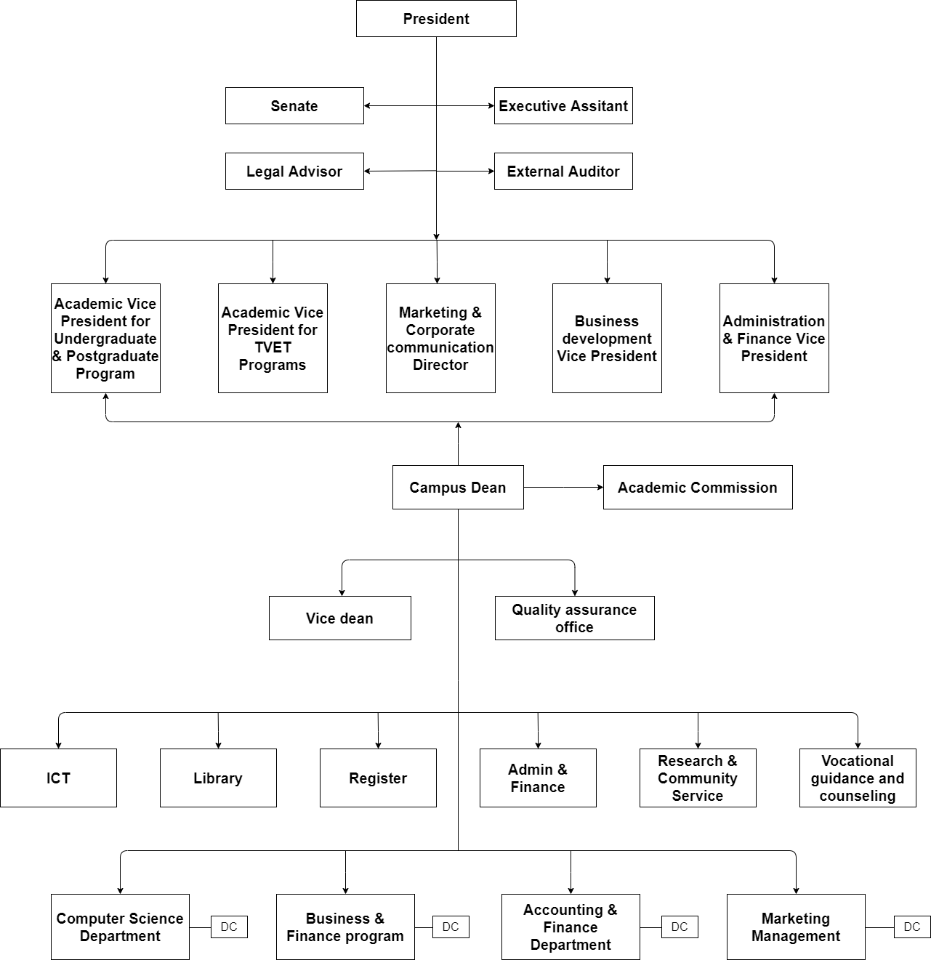

Figure 1 Structure of the organization [2]

**Description of the structure**

• **President**: The university's president guides, creates and puts into action a comprehensive plan that builds on the institution's current achievements. It also provides direction for a team of executives. Presidents oversee the board of directors and perform high-level managerial duties that relate to the business's overall operations.

• **Senate**: Has the responsibility to regulate and superintend the teaching and discipline of the University and promote research.

• **Executive Assistant**: Planning, customer relations, system creation, and management are just a few of the duties that the executive assistant is responsible for.

• **Legal Advisor**: The role of a legal advisor includes providing legal advice, taking part in legal proceedings, drafting legal documents, and enlightening clients or organizations about all relevant legal issues.

• **External Auditor**: An independent assessment of the university's yearly financial accounts is provided by a third-party auditor.

• **Academic vice president for undergraduate and postgraduate programs**: Managing and expanding graduate and undergraduate academic programs requires leading, coordinating, and supervising these tasks.

• **Academic vice president for TVET programs:** accountable for managing the academic department that composes TVET's traditional type of instruction.

• **Marketing & corporate communication director**: Assigned the responsibility of fostering and enhancing the company's business relationships.

• **Business Development president**: Maintain a record of your company's progress reports and win/loss information.

• **Administration and Finance Vice President**: In managing the planning, creation, implementation, and upkeep of the university's services and departments, it is important to uphold, support, and promote profitable goals and objectives.

• **Campus Dean**: a university administrator who manages a huge number of departments and is accountable for academic, programmatic, managerial, and budgetary matters.

• **Vice Dean:** The Vice Dean will play a significant role in developing and carrying out the University's education strategy within the faculty and ensuring that the Faculty Learning and Teaching Strategies are in sync.

• **Quality Assurance Office:** The Quality Assurance Office makes sure that the university's standards and rules are effectively applied.

• **Admin and Finance**: The administration is in charge of running the university on a daily basis. This requires supervising university staff members as well as working on student activities. Finance is the field that manages the budget, financial flow, and managerial responsibilities of the university.

• **Research and Community service**: provides information that aids in the creation of new technologies and equips us with the knowledge necessary to address issues relating to long-term community development.

• **ICT:** The department has the responsibility of monitoring the institution's and its departments' data and information integrity, as well as any information technology-related activities.

• **Register:** Register management is handled by the registration office. New student enrollment at the institution is the primary responsibility.

• **Library**: Offer a variety of books to students.

• **Accounting and finance department**: The role of the accounting and finance department are listed below:

• **Payroll**: A financial accountant oversees the process of paying university employees.

• **Budgeting**: Financial evaluation of plans, normally every month.

• **Taxation**: Used to raise revenue for the service and income to support the community's needs.

• **Supporting business strategy**: The finance director is a member of the executive team and is responsible for providing a financial environment that supports the business strategy.

• **Business and finance program**: Business finance, a subject of finance that examines how businesses handle funding sources, capital structures, accounting, and investment decisions, is the focus of this department.

• **Computer science department**: Department that supervises the academic activities of computer science students and includes all lecturers and students in the field.

• **Marketing management:** The department is designed to prepare students to perform critical business functions such as directing the flow of products and services from the producer to the consumer.[2]

## **1.2 Background of the project**

Project title: “Complain management system for Admas University” is a web-based application designed to handle and manage complaints computerized. The complaint management system is used to record, resolve, and respond to complaints. The system will improve the response time of the university management in addressing the complaints from the students, instructors, and staff.

## **1.3 Statement of the problem**

Since complaints are handled manually. When a complainant wants to file a complaint, they must do everything manually. As a result, filing a complaint and responding to a complaint are difficult.

The following statements are primary issues:

* The current system has no alternative way to complain. Anyone. Those who wish to file a complaint should do so in person at the office. However, some students do not have time to visit the offices. There is no other way to report their issue.
* One of the main problems with the current system is the lack of well-organized, measurable processes for dealing with grievances and receiving complaints.
* Time-taking process (performance issue): since the current system is done manually, it takes a lot of time to respond.
* The existing system lacks transparency in responding to complaints. This means that the complainant does not always get to see evidence or information about why they received the response.
* Data loss the current system is paper based data can get lost easily and some files may become damaged after a certain period.
* Finding and retrieving data is difficult.
* Security is very low.

## **1.4 Team composition**

This project is conducted by six members. Each member has their own duties and responsibilities within the project activities. They collaborate with our group to accomplish a common objective. This group has conventional knowledge of site improvement. The table below lists everyone's specific responsibilities and tasks.

|  |  |  |  |  |
| --- | --- | --- | --- | --- |
| **Project title** | **Complain management system** | | | |
| **Project team** | **NO** | **Name** | **ID** | **Responsibility** |
| 1. | Beshir Abdurahman | 0397/19 | Designer &Tester |
| 2. | Gebire Damite | 0646/19 | Developer, Tester & Designer |
| 3. | Hana Wedaje | 0962/19 | Designer & Technical writer |
| 4. | Meaza Mehari | 0657/19 | Web Developer, Project manager, Technical writer & Designer |
| 5. | Sumaya Osman | 0221/19 | Web Developer & Tester |
| 6. | Yordanos Getachew | 0632/19 | Web Developer, Technical writer & Project Architect |
| **Advisor Name** | Wolde Janfa | | | |

*Table 1 Team Compositions*

## **1.5 Objectives**

### **1.5.1 General Objective**

The aim of this project is to create Complaint Management System for Admas University.

### **1.5.2 Specific objective**

To achieve the general objective, which is stated above the following specific objectives are listed below: -

* To evaluate the existing paper-based information of complaint management system.
* Identifying problems of the Existing System.
* To propose solutions for the problems that are listed above.
* To design the proposed system.
* To build and implement the proposed system.
* Identify functional and non-functional requirements for the new systems
* To identify the specifications for an effective and user-friendly suggested system.
* To implement and test the system based on the specified requirements
* To deploy and maintain the new system.

## **1.6 Feasibility Analysis**

A feasibility study is an essential step in the research and software development processes. It allows us to assess the product under development. Feasibility study is carried out based on many purposes to analyze whether software product will be right in terms of development, implantation, contribution of project to the organization etc. It refers to our project's feasibility study in terms of product outcomes, operational use, and the technical support needed to implement it. We answer the question, "Is it worthwhile to implement this project?" The following result from the evaluation: [5]

### **1.6.1 Operational feasibility**

The system's user-friendly interface makes it easy to operate. Because of its simple structure, the system is independent of any platform, and the system user can be trained easily, making it operationally practical.

### **1.6.2 Technical feasibility**

The project team has the technical feasibility and capacity to develop the project. The project's focus is to develop a well-organized, dynamic website that is effective and efficient for managing complaint management systems. The proposed system is a website built with back-end tools including PHP for hypertext processing and MySQL for database system.

### **1.6.3 Economic feasibility**

The system to be developed is economically feasible, and the benefits outweigh the cost. This project benefited the organization by computerizing the existing system and lowering the cost of materials used in manual operation.

### **1.6.4 Political feasibility**

The proposed system is subject to all Adams University rules and regulations. The proposed system does not conflict with legal requirements, the government, or Adams University. It meets the rules and regulations established by the government (Ministry of Science and Higher Education) or Adams University.

### **1.6.5 Schedule feasibility**

Since there is enough time to finish the project on schedule, the suggested system can be implemented and deployed. A strict schedule will be used for the project to finish all tasks on time.

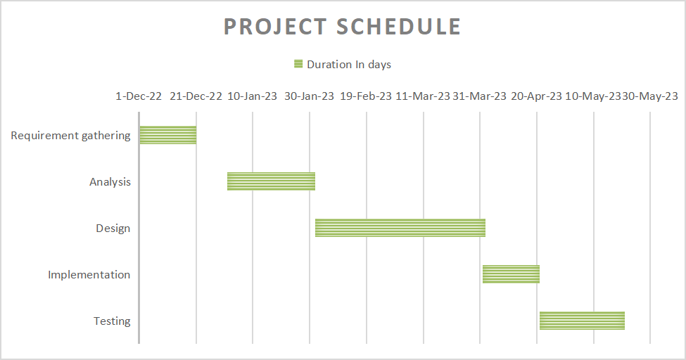

*Figure 2 project schedule*

## **1.7 Scope and significance of the project**

This system includes the following main features:

* Register instructors on the system.
* Register students on the system.
* Receiving student and teacher complains.
* Record the complaints.
* Distribution of related complaints among Different Department.
* Complaints solving within 24/7 hours otherwise complaints will be forwarded to head department and department head will giving responses to the complaints.

In general, the significance of this project is to improve the database and enhance the effectiveness, efficiency, and security of the system. Specifically, to Admas University, it simplifies the compliance process to be easy and anyone can send his/her complaint from anywhere and anytime using their smartphone. It also reduces the paperwork.

## **1.8 Target beneficiaries of the system**

1.Admas University

* The system assists the university in handling complaints, managing, responding to them, and storing all relevant information for quick access.
* It also enables the university to handle complaints swiftly and fairly while also being transparent and accountable.

2. Department Head

* This system makes it simple for department heads to keep track of complaints and giving respond.

3. Student

* The system enables students to appropriately file complaints, receive responses without having to visit the offices repeatedly until the issue is resolved, and save time.

3. Instructors

* The system will make it simple to respond to complaints, and they will provide official responses and make the process transparent.
* They can complain without having to go to work, which saves them a lot of time.

4. Stuff

* The system will facilitate responding to complaints, allow for a formal response, and increase transparency. Additionally, it helps individuals file complaints without having to visit the office, which saves them a lot of time.

## **1.9 Methodology for the project**

The team chose object-oriented programming because it provides several benefits, such as the following:

* It makes the code reusable.
* It is fast and easier to execute.
* It provides a clear structure for the programs.
* It makes it possible to create a fully reusable application with less code and shorter development.
* Helps to keep the code DRY “Don’t Repeat Yourself” and makes the code easier to maintain, modify, and debug.
* The data hiding rules help the programmer to make secure programs that cannot be invaded by code in other parts of the program.

### **1.9.1 Data source**

Data is a collection of facts, figures, objects, symbols, and events gathered from a variety of sources. The team collected data to learn more about the existing system, allowing them to improve it. We gathered data on an as-needed basis from various data sources because this team could not make informed decisions without it.

* **Primary source:** This team obtained data by interviewing Admas University department heads and student.
* **Secondary source**: The documents acquired from the head office and documentation written about the organization served as our secondary data sources and website of Admas university.

### **1.9.2 Data collection**

The following techniques were employed as the primary data source.

• **Interview:** we interviewed the staff of Admas University and the student. We obtained the appropriate kind of responses to our inquiries.

The following are the questions we asked the student:

**SECTION 1: CONSIDERING A COMPLAINT N.B: If you have taken your** complaint further, please think about the initial complaint that you made to the Admas University.

Q1 Where did you get the initial information on how to make your complaint?

**SECTION 2: MAKING A COMPLAINT**

Q2 Did you feel that you were taken seriously when you first raised your complaint?

Q3 Was this your first attempt to make this complaint?

Q4 If this was not your first attempt to make this complaint, please describe where and how you first tried to make your complaint?

Q5 How did you make or how were you advised (by the University) to make your complaint?

Q6 Was this your preferred method of making your complaint?

Q7 Did you find it easy to raise your complaint?

Q8 Why did you feel it was not easy to make your complaint?

Q9 What sort of issues (complaints)did you have, and to whom did you bring those issues up?

**SECTION 3: ACKNOWLEDGEMENT OF COMPLAINT**

Q10. Were you offered a discussion about your complaint?

Q11. Was this discussion at a time of your choice?

Q12.Were you informed of a timescale for responding to your complaint?

**SECTION 4: STAYING INFORMED**

Q13.Did you feel that you were updated enough about what was happening to your complaint?

Q14. If you received updates about your complaint before you received the outcome?

**SECTION 5: RECEIVING THE OUTCOME**

If you have not yet received the outcome of your complaint, please go to Section 5: Reflecting on the Experience

Q15. Did you receive the outcome of your complaint within the given timescales?

Q16. In what format did you receive the outcome of your complaint?

Q17. Did you feel that this was the right format for the outcome of your complaint?

Q18. Was the outcome of your complaint explained to you in a way that you could understand?

Q19. Did you feel that the response you received addressed the points you raised in your complaint?

Q20. Did you seek an additional response for the points that were not addressed?

Q21. Were you satisfied with the outcome of your complaint?

Q22. Were you made aware of your right to take your complaint further if you were not completely satisfied with the outcome and/or the recommendations?

Q23. Did you feel that your complaint was handled professionally by the University you complained to?

Q24. Why did you feel that your complaint was not handled completely professionally?

Q25. In your experience of making a complaint, what do you think worked well?

Q26. How easy did you find it to make a complaint?

**SECTION 6: ABOUT YOU**

These questions should be answered about the person who made the complaint

Q27. Are you a student?

Q28. What department do you study in?

Q29. If you are student, what is your class year?

**SECTION 7: FURTHER COMMENTS**

Please use this section to let us know if there is anything else you would like to tell us about your experience of making a complaint.

Q30. Is there anything that worked particularly well about the complaints process?

Q31. Is there anything that could have been better about the complaints process?

The HR department was asked the following questions:

Q1. Does the university have a complaint management system?

Q2. How does the university receive complaints?

Q3. Was this the preferred method of receiving complaints at the University, and if so, why?

Q4. How many forms does the University have, and for whom are they designed?

Q5. What is the procedure for handling complaints at the university?

Q6. How do you collect information or evidence to solve a complaint?

Q7. What is the way the university responds to the complaint?

Q8. Is it transparent how the university responds to complaints, such as by showing them evidence of why you gave those responses?

Q9. How long did the university take to respond to the complaint?

Q10.Does the university provide time frames to the complainant on how long it will take to respond?

Q11.What kind of method does the university use to respond to complaints?

Q12.Can you provide an opportunity for the complainant to discuss their complaint?

Q13. Was this discussion held at a time that was convenient for you?

Q14.What are the challenges you face when dealing with complaints?

Q15.What are the university's rules if you receive a complaint that you are unable to respond to, and to whom do you refer the problem?

Q16.What can the complainant do if they are not satisfied with the responses?

Q17.Do you believe the current complaint system handles complaints professionally?

Q18.What do you think worked well, and why, in your experience receiving a complaint through the existing system?

Q19. Based on your experience receiving a complaint, what do you think should be changed in the existing system and why?

Q20.What are the university's business rules for handling complaints?

Q21.How does the current system generate reports?

Q22. What sort of issues (complaints)did you have, and to whom did you bring those issues up?

Q23. Did you receive the outcome of your complaint within the given timescales?

Q24 In what format did you receive the outcome of your complaint?

Q25. Did you feel that this was the right format for the outcome of your complaint?

Q26. Was the outcome of your complaint explained to you in a way that you could understand?

Q27. Did you feel that the response you received addressed the points you raised in your complaint?

Q28. Did you seek an additional response for the points that were not addressed?

Q29. Were you satisfied with the outcome of your complaint?

Q30. Were you satisfied with how they handled complaints?

Q31.Do you think the university requires a new complaint system?

Q32.What is your expectation of what the new system should include?

• **Questionnaire:** also gathered survey responses from the students. We received the right answers to our questions.

The following are the questions we asked the student:

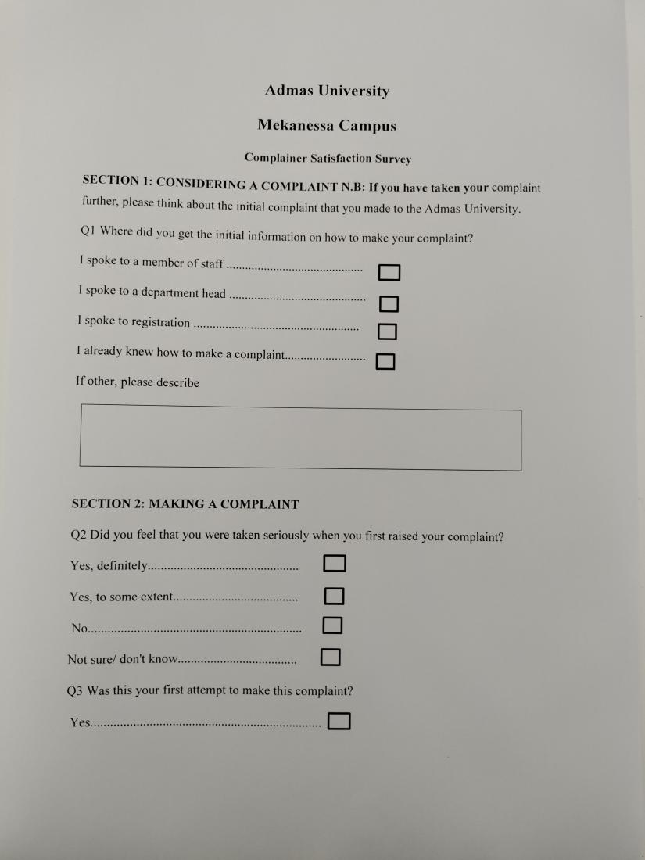

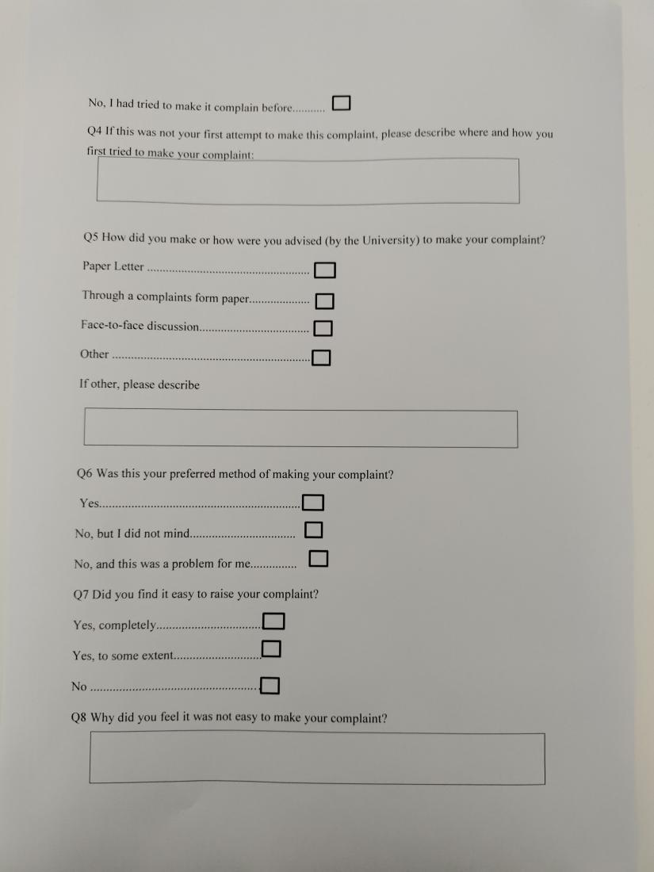

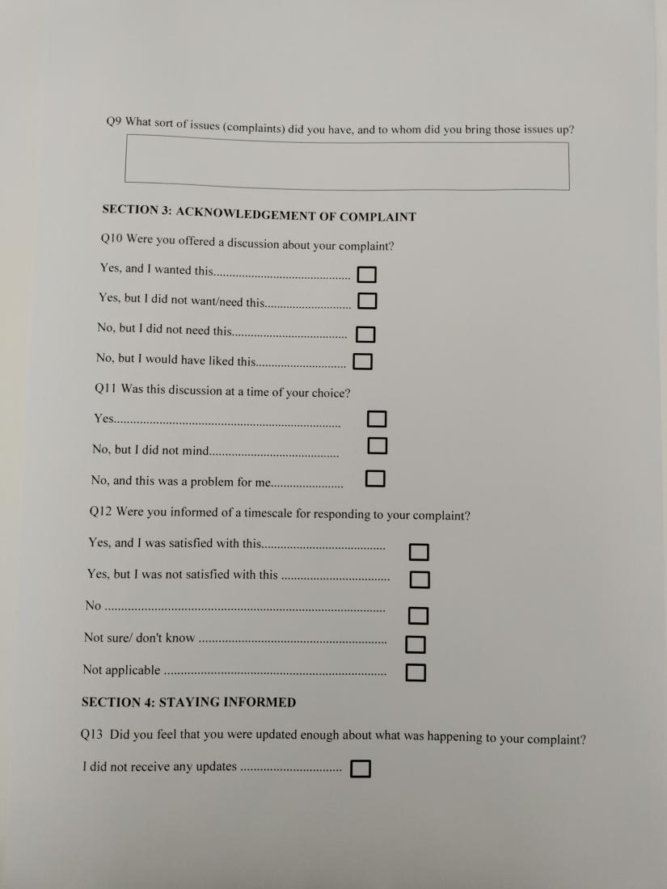

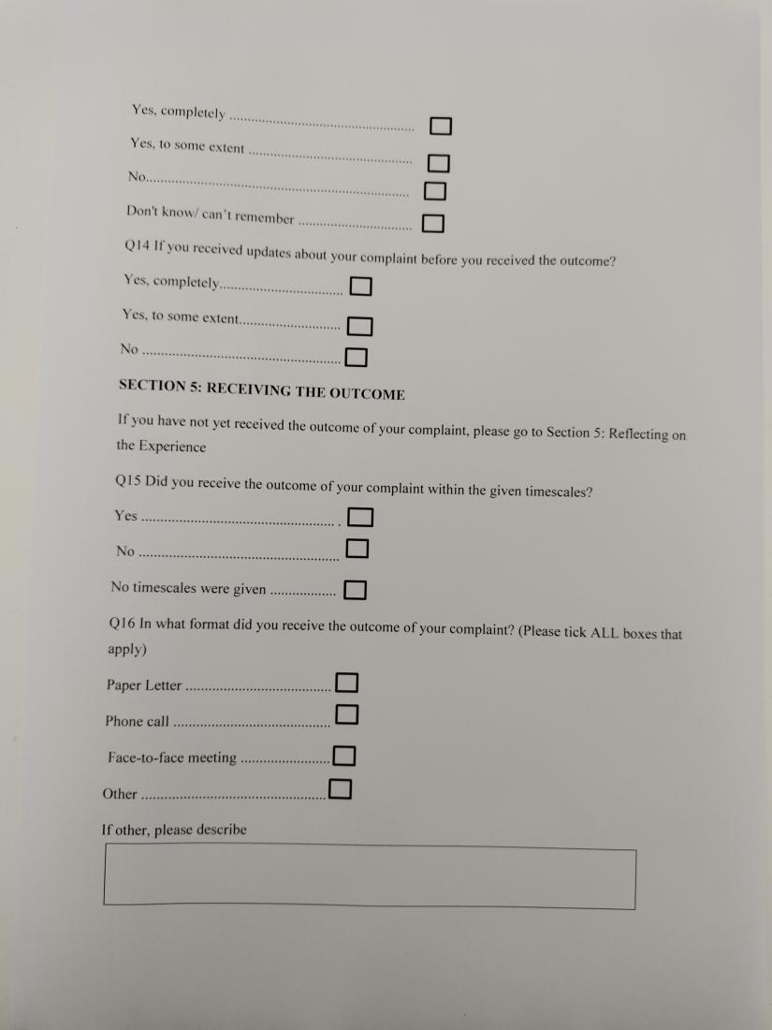

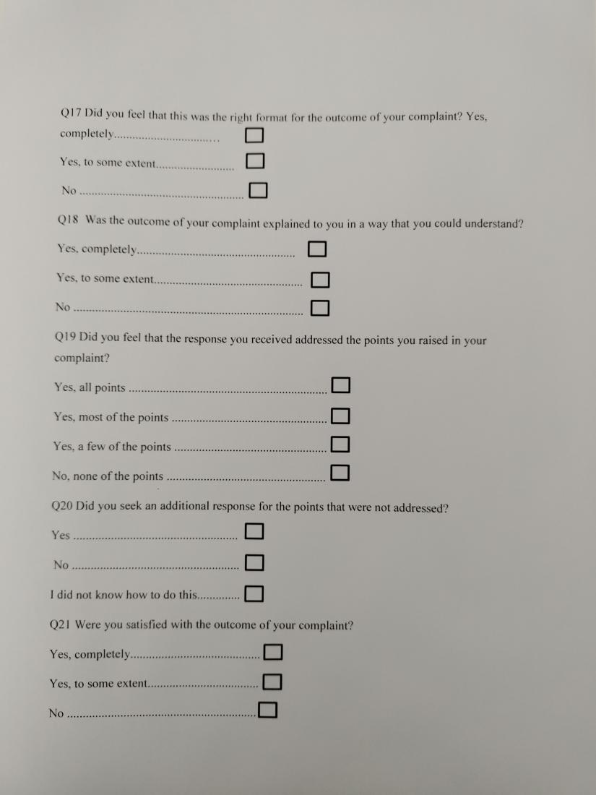

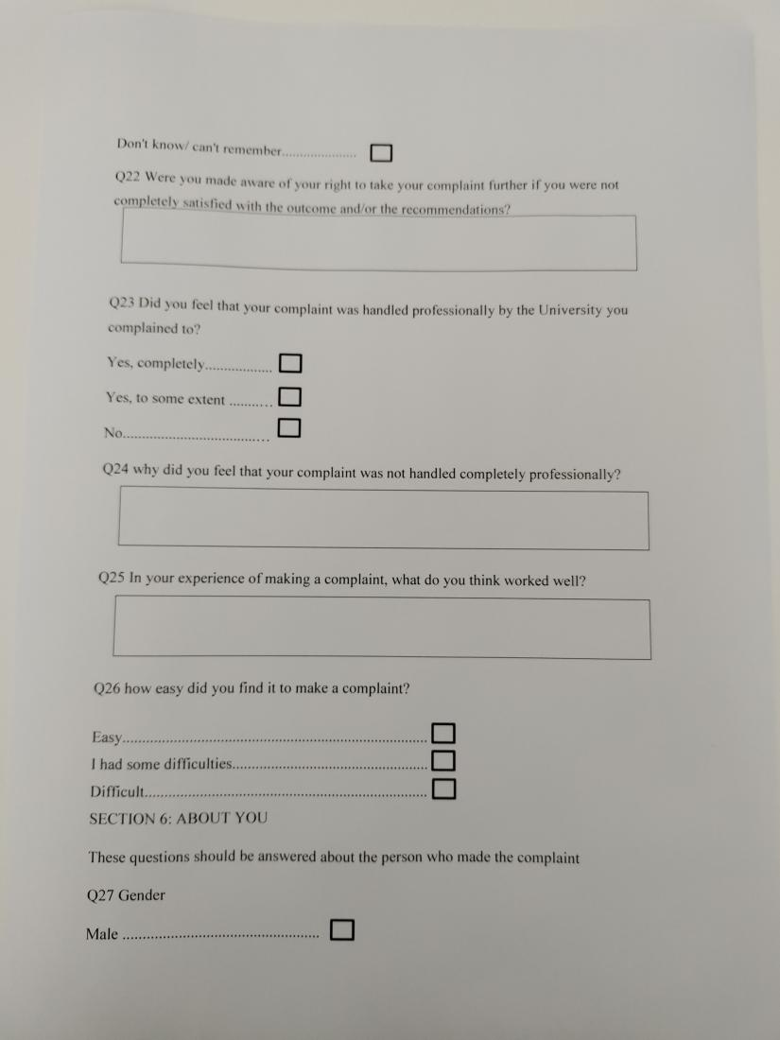

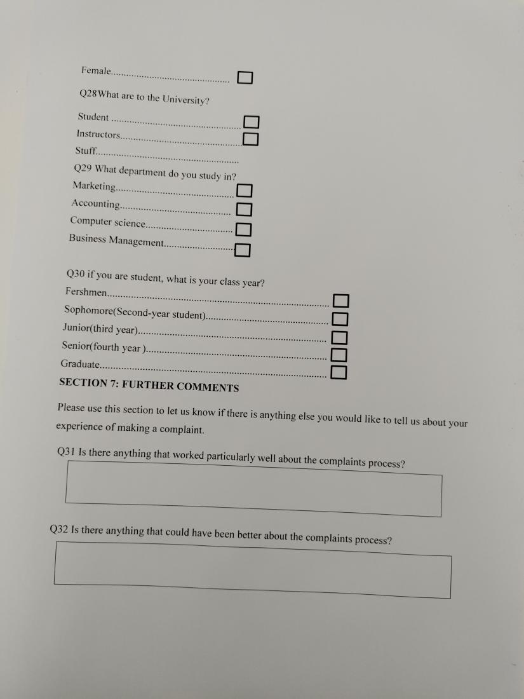

Image 1: Questionnaire

**Observation:** we observed the current system of Admas University, and we were able to find out the drawbacks of the existing system that our system is going to solve.

The following techniques were employed for the secondary data source:

• **Website:** we collected information for the organization's website. collected data about what we are planning to do.

### **1.9.3 System Analysis and Design Methodology**

We chose object-oriented system design analysis and implemented it using a unified modeling language (UML) model. We chose UML because we wanted our system design to be consistent, simple, and maintainable. Easy to understand, readability, and reusability help in program planning before programming.

**1.9.4 Development Environment and programming Tools**   
  
To complete this project, various development tools are essential. So, here is a list of the resources we used to create our project.

* Font-End Design Tools
* HTLM: Hypertext Markup Language is used for describing the structure of Web pages.
* CSS: is used to style and layout and describing the presentation.
* JavaScript: It allows us to add dynamic behavior to the web page and add special effects to the web page.
* Font awesome: is the internet's icon library and toolkit used by millions of designers, developers, and content creators.
* Back End Design Tools
* PHP: is an open-source scripting language that is suited to web development.
* MySQL: is used for Database design and storage.
* Development environment
* XXAMP server: used to create a local web server for testing and development. It is a package containing Apache2 Server, PHP, MySQL database, and PHPMyAdmin.
* visual studio Code: is a powerful code editor with many features that support web developers.
* Drawing tools: [draw.io and](http://www.draw.io.and) lucidchart

### **1.9.5 Testing**

Testing recognizes computer program bugs and guarantees that a program or framework is prepared for usage. The process of analyzing and approving a computer program item or program to ensure it does what it is expected to do is known as computer program testing. The benefits of testing incorporate anticipating bugs, identifying a mistake on the off chance that it happens at an early stage, sparing time, decreasing improvement costs, and moving forward with execution.

There are mainly four types of testing in software testing:

1. **Unit testing**: check if software components are fulfilling functionalities or not.

2. **Integration testing: it** checks the data flow from one module to other modules.

3. **System testing: This** evaluates both functional and non-functional needs for testing.it ensure that all system elements work together properly to achieve a system wide functionality and performance.

4. **Acceptance testing**: checks that the requirements of a specification or contract are met as per its delivery.

It would be tested to look for any problems that would affect the framework's functionality. Unit testing is the main test. The designer will do a unit test to ensure that each unit is functioning. The engineer tests the integration of numerous linked modules that have been color-coordinated, coordinated, gathered, and coordinated. The goal is to find module interference problems, which implies determining whether individual units can lawfully coordinate into a subsystem, notably integration with the database. The third stage involved framework testing, where engineers and framework analysts ran a complete coordinates application from start to finish. The goal is to determine whether the application satisfies the requirements for commerce. Before launching the framework, acknowledgment testing carried out by the final client ensures that the arrangement satisfies the established trade standards with a defined standard of quality.

### **1.9.6 Implementation**

The process of carrying out a plan, a method, or any other design, idea, model, specification, standard, or policy is known as implementation. In our situation, "complete implementation" refers to the installation and delivery of the full system into production.

**Partial/phased implementation**

When small parts of the new system gradually replace small parts of the old system in a partial/phased implementation, the implementation method is said to be phased. Different features of the new application are used, while features of the old system are removed. This approach enables an organization to gradually transition from one system to another.

## **1.10 Limitation of the project**

* The system does not allow parents to file complaints.
* The proposed system can’t be accessed without an internet connection.
* The proposed system may be difficult for disabled people to use.
* The proposed system is developed to send notification only to the recipient e-mail address not mobile phone (phone number).

## **Chapter Two**

## **Description of the Existing System**

This chapter intends to describe the existing system, the existing system's players who take part in the complaint management system and response process, and the major functionalities of the existing system.

## 2.1 **Introduction of Existing System**

The current system handles complaints manually. In the existing system, complainants must file a form prepared by the university. The department head will handle the complaint accordingly and giving responds. To respond to the complaint, the department head will gather information and evidence and make decisions based on the information gathered. The response time for complaints may take up to six or seven days, but it usually takes longer. The department head will contact the complainant and inform them of the responses. In some cases, complaints are written on paper and presented to the grievance handling officers. Additionally, in the existing method, some complaints are expressed orally

## 2.2 **Players in the existing system**

Admas university compliant management institutions have some users that are participating in the existing system. These are: -

* **student:** A student is a university member who wishes to have his or her complaint forwarded to the university office.
* **Instructor:** receive complains from students and solve the respective problem and send it back to the Complains manager.
* **Complaints managers/human resources** are in charge of receiving all complaints from complainers and responding to them.
* **Department heads:** are in charge of receiving all grievances from students and responding to them.
* **Dean:** is in charge of receiving and responding to all complaints.

## 2.3 **Major functions/activities in the existing system**

The major functions in the existing system are as follows:

* Manually handle complaints.
* **Accepting complaint:** Receive the user complaint through oral speech, form or by written paper.
* **Solving complaints (giving responses):** Addressing complaint problems and solving complaints. The complaint solving process depends on the type of complain. For instance, if the complaint is simple, it is directly solved orally in a short time otherwise it takes a long period of time.

## 2.4 **Business rules (Examination rule)**

The existing system doesn’t have any business rules.

## 2.5 **Report generated in the existing system**

## **2.6 Forms and other documents of the existing systems**

The existing system have the following form:

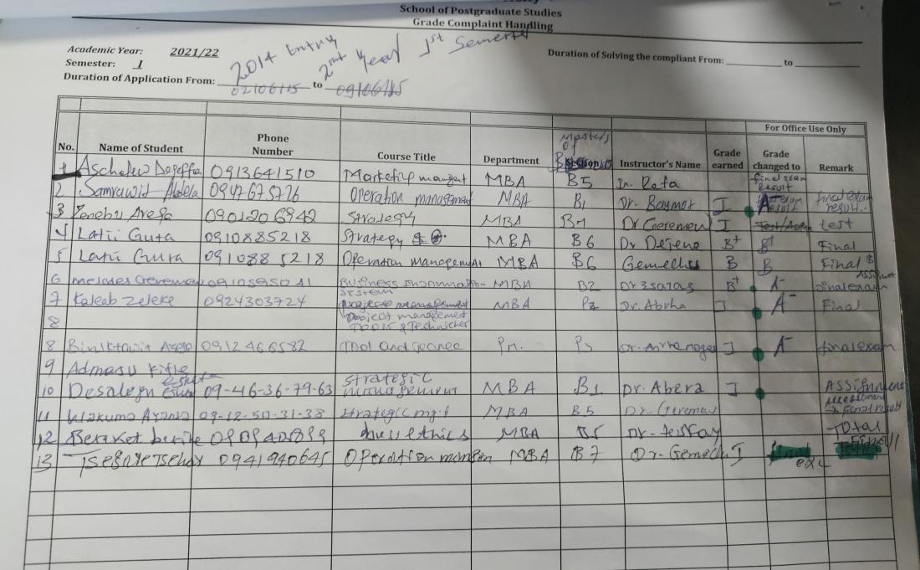

Image 2: Student complain handling form

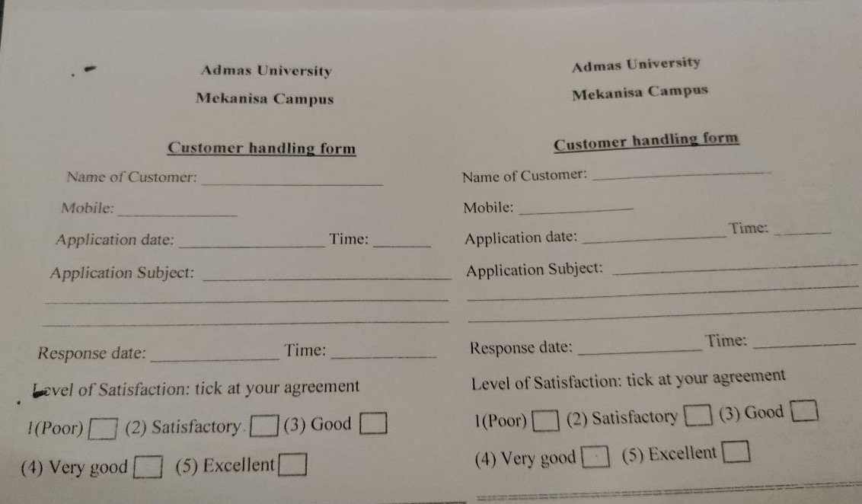

Image 3: Customer handling form

## 2.7 **Bottlenecks of the existing system**

### **2.7.1 Performance (Response time)**

* The current system takes between 6 and 7 days to solve the problem.
* Since the current system is done manually, it is hard to interpret what the complainer wanted to say due to poor handwriting, lack of information, or misinterpretation so the current system does not perform accurate and quick response.

### **2.7.2 Security and controls**

* The file system is less secure so files can get lost, mishandled, misplaced, or damaged. Once the file is destroyed or lost there is no way to retrieve it.
* Since the existing system is paper based, it has less security management system.

### **2.7.3 Service**

* The current system causes delays in giving a response to the complaint.
* The current system service is not fast as it should be. Therefore, the service provided by the university through manual systems is not sufficient.

### **2.7.4 Efficiency**

* The current system is inefficient because there are no tools to automate handling complaints or receiving complaints. As a result, handling complaints could take six or seven days and sometimes it could take more than that.

### **2.7.5 Flexibility**

* The system should be flexible so that anyone with an Internet connection can use a desktop, tablet, or smartphone to access it.

## **2.8 Proposed solution for the new system that address problems of the existing system**

From the below analysis we chose web-based application because the rest alternative is platform dependent, but the web-based application reconciles those issues

|  |  |  |
| --- | --- | --- |
| Possible solution | Cons | Pros |
| 1. Mobile application | * difficulty to create * the cost to create them * the cost to make them available to people * the need for updates and support. | * Convenience * easy communication with customers * online usage |
| 1. Desktop application | * Needs to be manually updated. * Platform limited. * Needs to be downloaded and installed. | * App runs locally * Offline access * Security * Speed * Installation required |
| 1. Web-based application | * Website Dependency * Reduced Speed * Less secure. * Slower performance | * Cost-effective * Always up to date. * Free from Downloading needs. * Runs easy. |

As previously stated, the institution is having difficulties with complaint responses, performance, and storage, so the proposed solution is:

* To make the complaint process automated and simple.
* To build a database where complaints and responses can be stored.
* To make responses transparent and fast.
* To increase security and availability.

## 2.9 **Requirements of the Proposed System**

### **2.9.1 Functional requirements**

Functional requirements for the proposed system are listed below

* The system should allow the registration of all employees in the organization such as employee instructors, students, and administrators.
* The system should require a login before allowing anyone to use any functionality of the system
* The system should allow the complainer to register complaints.
* The system should allow complainers to attach their evidence.
* The system should allow complainers to send their complaints.
* The system should allow the complainer to view and update (edit) their complaints.
* The system should allow the complainer to receive email notification after their complaint is solved.
* The system should send a notification via email to the person who is responsible for giving a response to the complaint
* The system should allow instructors to receive complaints from students.
* The system should allow instructors to view complainer complains
* The system should allow the instructor to respond to the complaint.
* The system should allow the complaint to be escalated to the department head after a few days.
* The system should allow the department head to receive and view complaints.
* The system should allow the department head to give responses to complaints.
* The system should allow escalate the complaint to the dean if the department head doesn't respond.
* The system should allow the dean to give response to complaints.
* The system should allow administrators to manage the accounts.
* The system should allow administrators to manage complaints status.
* The system should allow the administrators to retrieve any complaints.
* The system should allow administrators to add departments.
* The system should allow to logout all employees in the organization.

### **2.9.2 Non-functional requirements**

Non-functional requirements for the proposed system are listed below.

* **Security**:
* The system should not allow unauthorized users to access it.
* Security includes authentication and authorization of users as well as secures compliant information. Any user who wants to login to the system must identify themselves using a login name and password.
* The system should validate user input to sensitive data to protect it from various web attacks.
* **Performance**:
* The system should be fast and give efficient service.
* The system should retrieve data and it should take less time.
* The system should be error free when accessing huge amounts of data.
* The system should be accessed by many users and should have fast response time.
* **Availability**:
* The system should be available 24/7.
* **Maintainability**:
* The software developer should be able to instantly rebuild any error that might occur.
* **Portability**:
* The system should work properly on any browser.

## **References**

[1]. Complaint English meaning - Cambridge ***Dictionary 2023, (***[https://dictionary.cambridge.org/dictionary/english/complaint)](https://www.google.com/search?sxsrf=AJOqlzU9T7KqR8kVmKKj9hfqmEfH0o_xAg:1677694983329&q=Complaint+English+meaning+-+Cambridge+Dictionary+2023,(https://dictionary.cambridge.org/dictionary/english/complaint)&spell=1&sa=X&ved=2ahUKEwie-JbsrLv9AhVTg_0HHYd3D2QQBSgAegQIChAB)

[2]. Admas University organizational structure, Admas University HR manual, 2021 A.A

[3]. Admas University Official website, 2022, (<http://www.admasuniversity.edu.et/>)

[4]. Admas University Hargessa website, 2021,([https://www.admasuniversity.com](https://www.admasuniversity.com/))

[5]. Types of Feasibility study in software, 21 Sep 2021, (<https://www.geeksforgeeks.org/types-of-feasibility-study-in-software-project-development/>.)